BRACT’s
Vishwakarma Institute of Technology, Pune
Practical Implementation Sheet
Department: CSE-AI Semester: 5 Academic Year: 2026-27
Division: E Batch: 1 Practical No: 7
Roll no: 42 PRN No: 12414728 Name of Student: Saachi Laturiya
Subject Name : Deep Learning

Problem Statement : Implement Transfer Learning using pre-trained AlexNet, VGG16, ResNet50 and EfficientNetB0 model for image classification and compare their performance.
Algorithm :
- Load the CIFAR-10 dataset and separate it into training and testing sets.
- Resize and normalize the images according to the input requirements of the pre-trained models.
- Load the pre-trained AlexNet, VGG16, ResNet50, and EfficientNetB0 models.
- Replace the final classification layer of each model with a new layer having 10 output classes.
- Freeze the pre-trained layers and train the newly added classification layers using the training dataset.
- Evaluate each model on the test dataset and calculate its classification accuracy.
- Record the training time of each model.
- Compare the performance of all four models using a results table and an accuracy comparison graph.

Code :
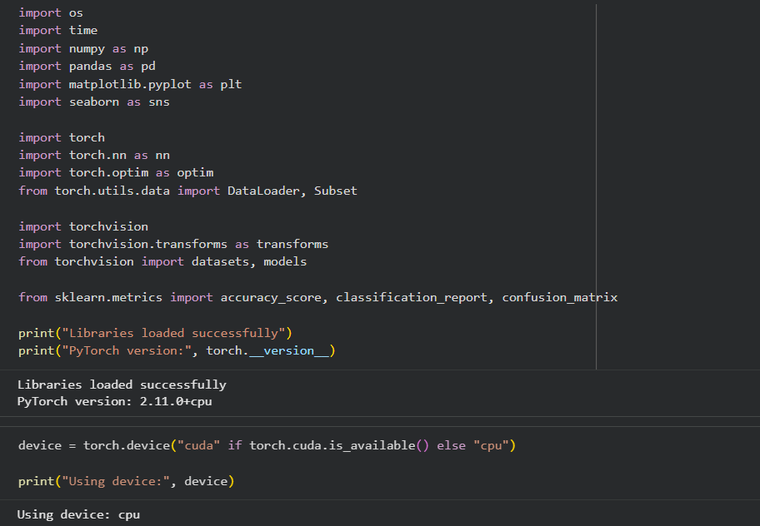
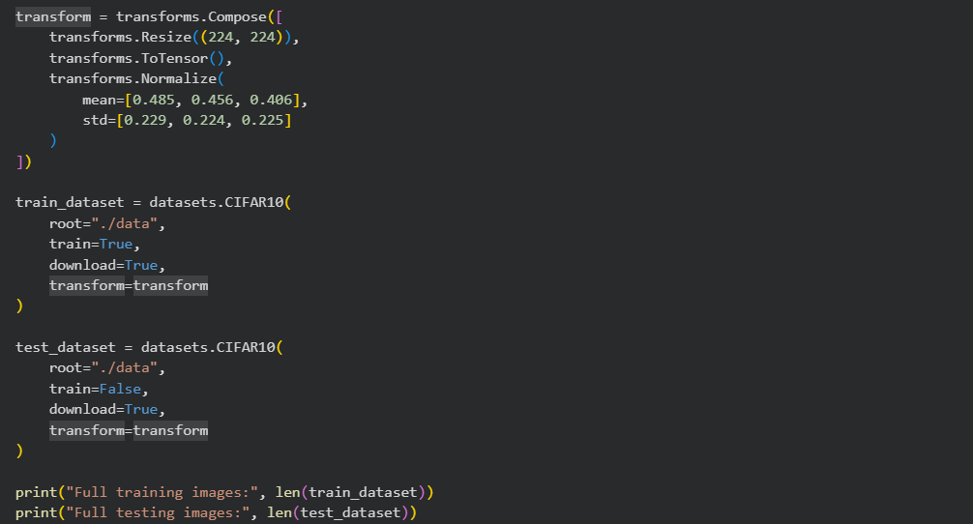
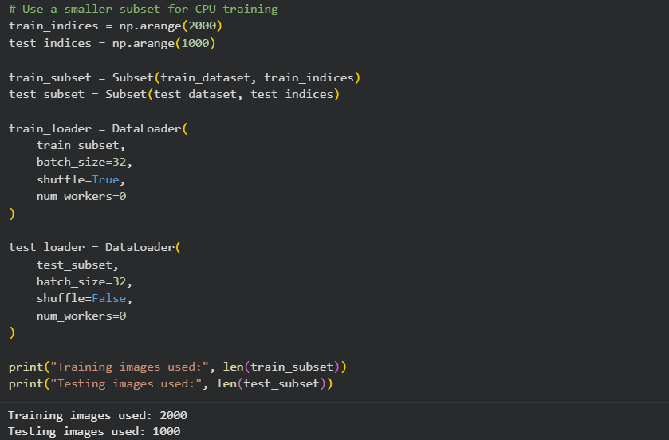
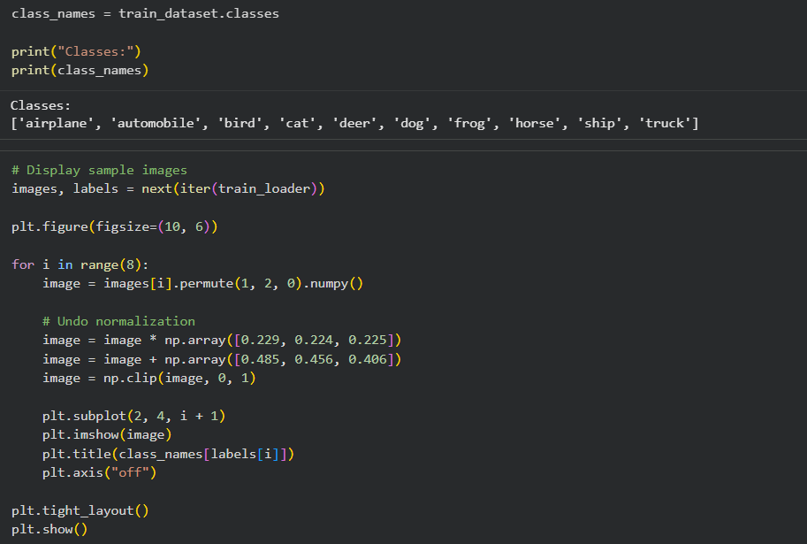
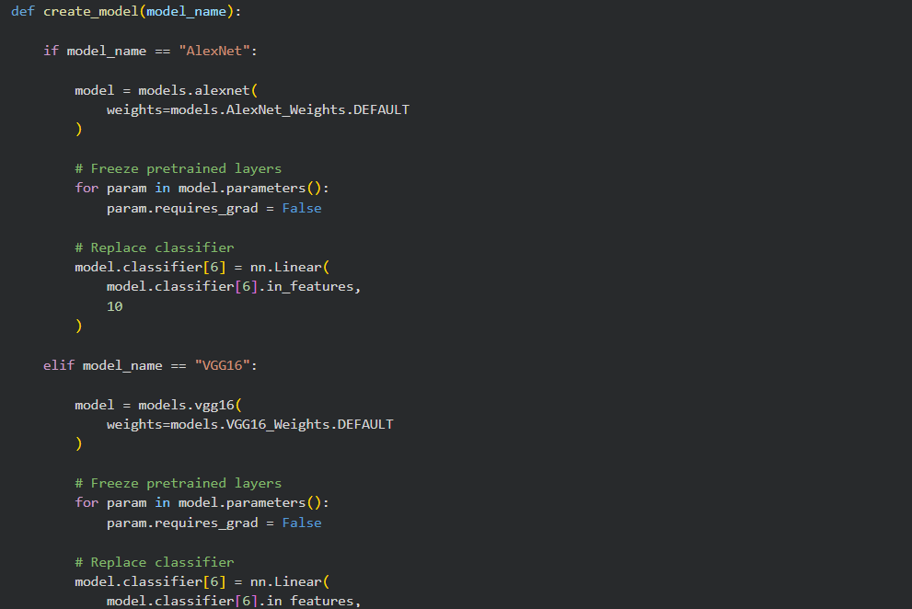
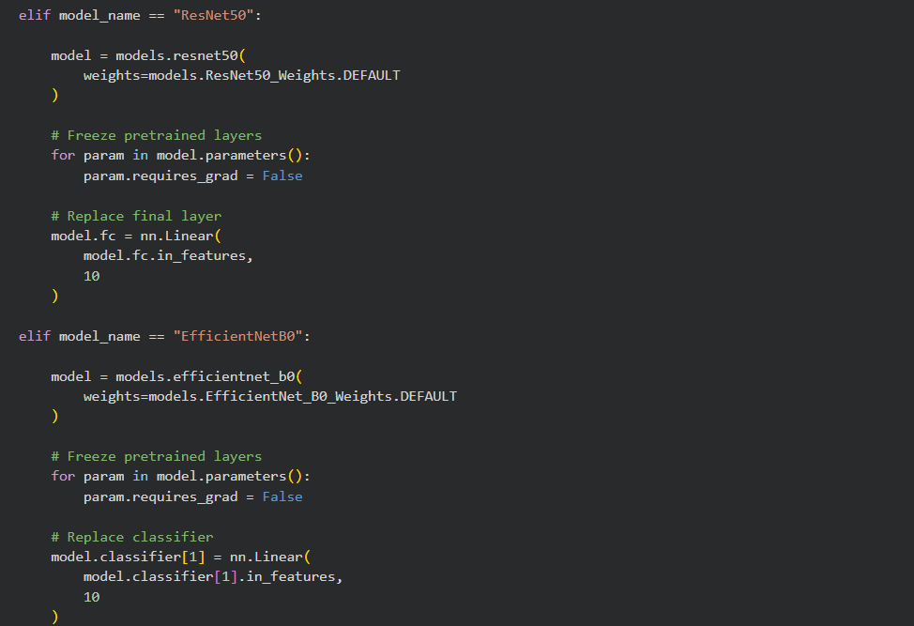
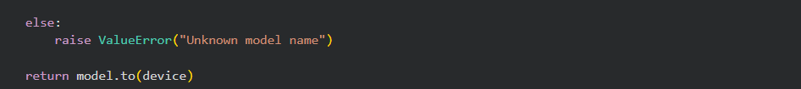
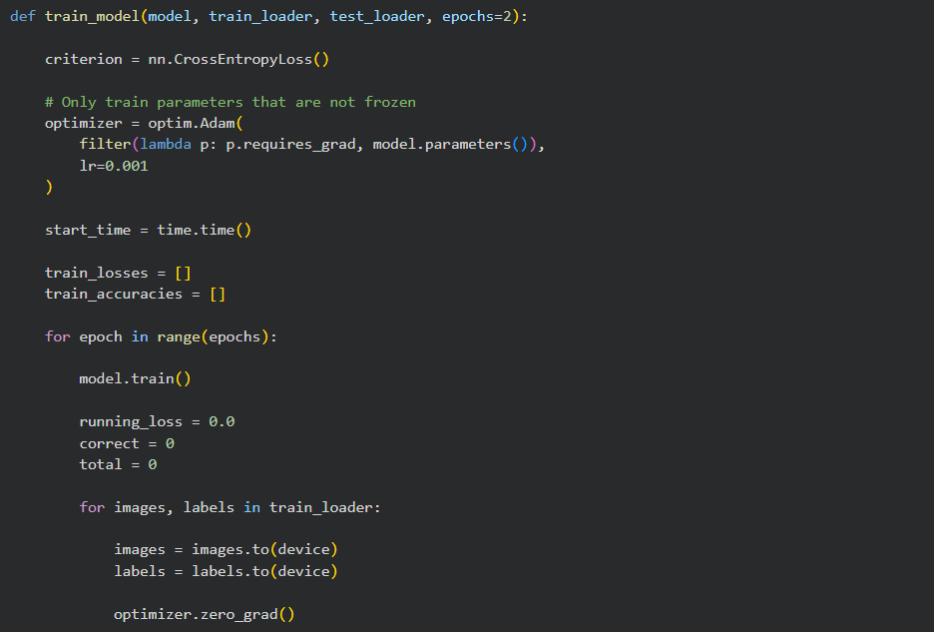
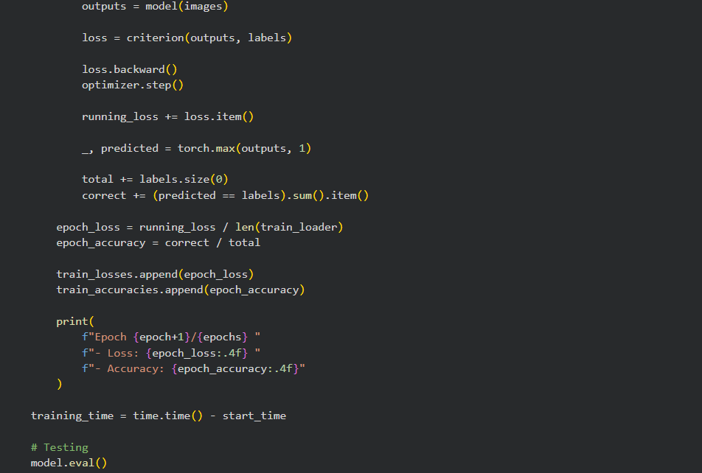
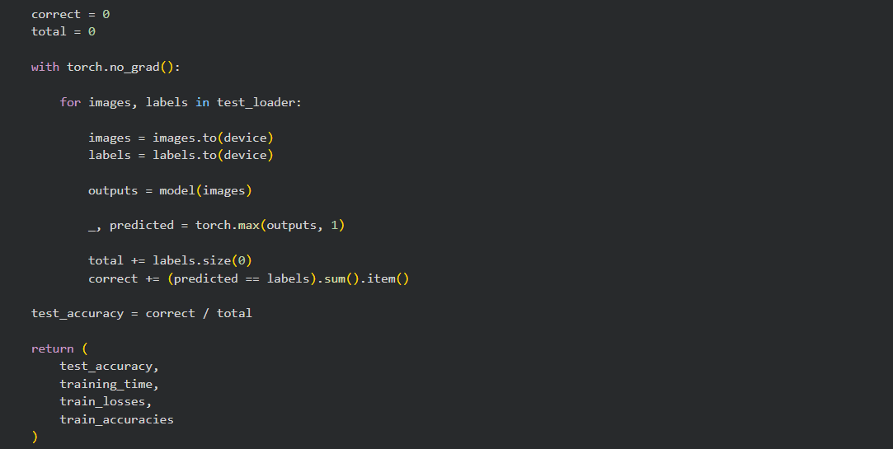
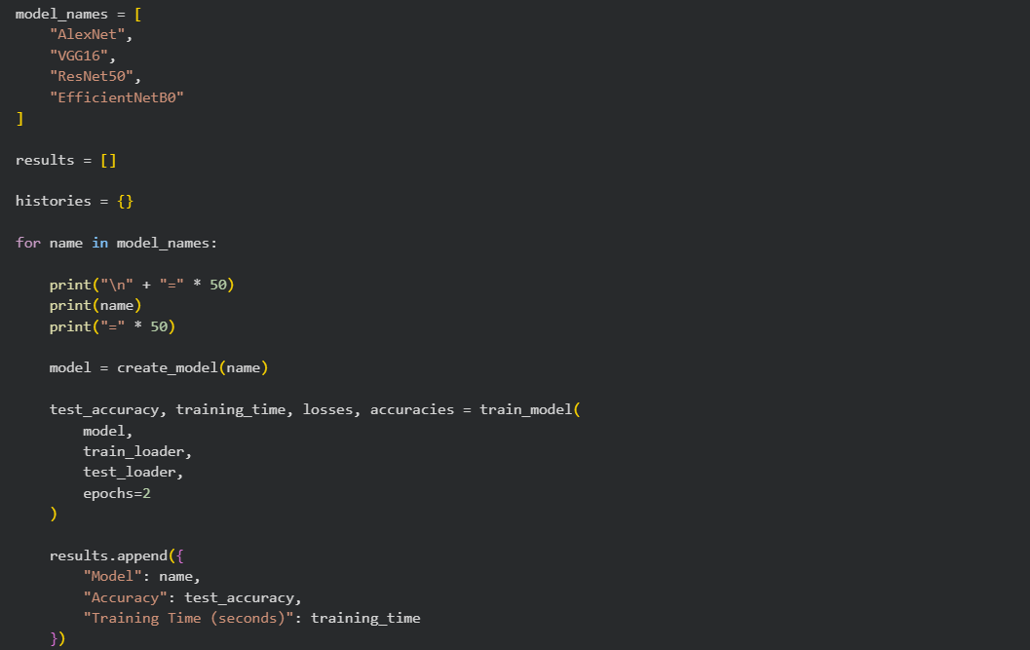
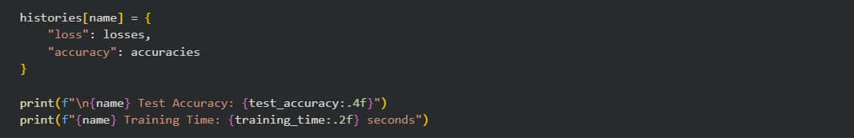

Output :
Figure 1: Sample Images from the CIFAR-10 Dataset
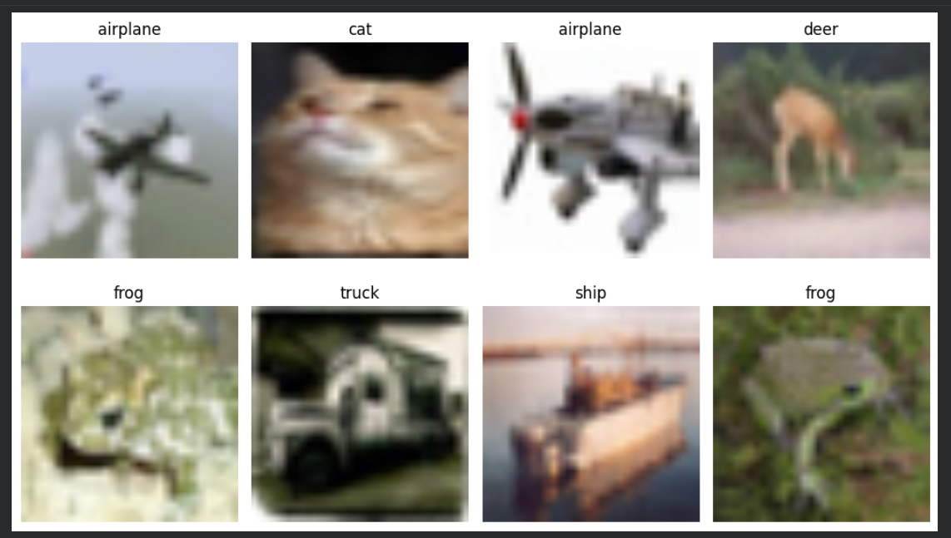

Figure 2: Training Performance and Test Accuracy of Pre-trained Models

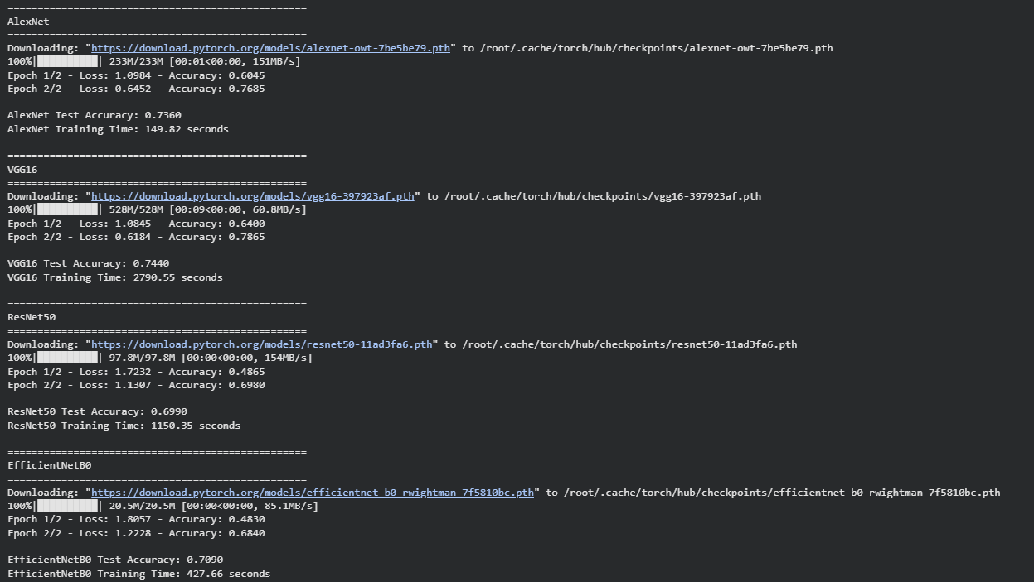
Table 1: Performance Comparison of Pre-trained Models

Model | Test Accuracy | Training Time (s)
AlexNet | 73.6% | 149.82
VGG16 | 74.4% | 2790.55
ResNet50 | 69.9% | 1150.35
EfficientNetB0 | 70.9% | 427.66

Conclusion :

Transfer learning was implemented using AlexNet, VGG16, ResNet50, and EfficientNetB0 on the CIFAR-10 dataset. Among the four models, VGG16 achieved the highest test accuracy of 74.4%, followed by AlexNet at 73.6%, EfficientNetB0 at 70.9%, and ResNet50 at 69.9%. AlexNet also required less training time than the other models. Thus, the experiment demonstrates how different pre-trained models vary in classification accuracy and computational time.

